Newsletter 36 2 December, 2022
Friends of the Reflection Gallery
“Reflecting faith’s experience”
An activity of the Montville Uniting Church
Greetings to you Friend. There is a wonderful new display in the Church Gallery.
Every culture that celebrates Christmas uses different things from that culture to help remember and celebrate the story of the birth of Jesus over 2000 years ago in Bethlehem. Earlier this year the congregation at Montville decided that this year for Christmas we would have a theme in the church for Christmas of a Bush Christmas. Are there things that come out of our Bush culture that can help us think about the birth of Jesus? Are there things in nature that help us reflect on the wonderful new life God offers to us in Jesus?

We have paintings on the wall of the church of Australian birds and animals and some others, not so Australian! The paintings are contributions from Joy Joyce, Dorothy Peall and Barbara Willcocks. You may enjoy reading about the origins of some of these birds and animals.

We have created in the church a bush Christmas scene. We have built a simple bough shelter. We have baby Jesus in a wooden crib similar to what aboriginals used to place their babies in. We have added to this some Australian animals and a billy can and fire. In our busy world, do we sometimes need to stop and have a cuppa with Jesus? A major feature of the bough shelter is a new banner made by a member of the congregation, Bernadette Woodward, hanging at the back of the shelter. The banner has a central cross made from an aboriginal print titled ‘Bush dreaming utopia.’ The people of Israel had been dreaming for centuries of the one who would come and give them new life where they would not live by the external law but with God’s law in their hearts. Aboriginal people are people of the dreaming. They dreamt of the past, present and the future. They dreamt of a coming Utopia. The birth of Jesus offers to the world that utopia.
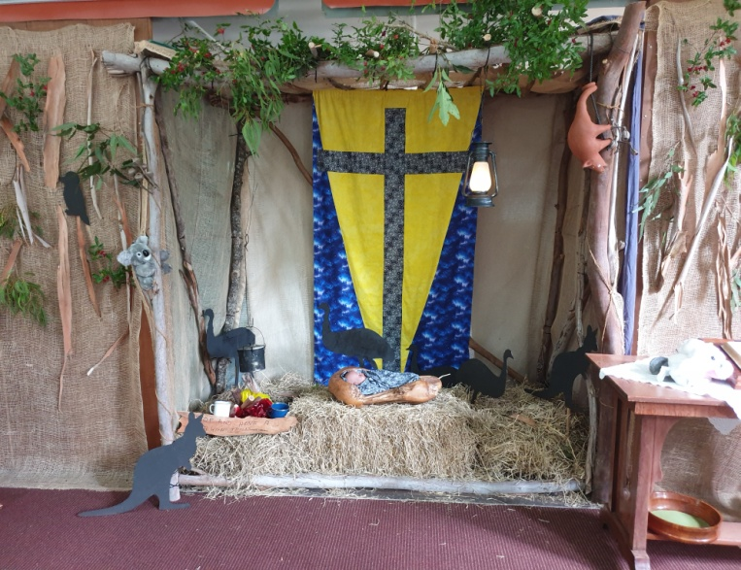
Finally the life of the bush reminds us of the possibilities of the wonderful new life God offers to all.

We can think about how the plants continue to grow and change. We can think about how new life comes from a seed in the ground. We can be drawn closer to God as we are inspired by all the beauty and diversity of nature. The words of an old hymn spoke of this:

When through the woods and forest glades I wander,
And hear the birds sing sweetly in the trees;
When I look down from lofty mountain grandeur,
And hear the brook, and feel the gentle breeze.
Then sings my soul, my Saviour God to thee,
How great thou art, How great thou art.

Have a great Christmas and enjoy the Bush Christmas.

Thank you for your support.

Please continue to pray for the Gallery and its outreach, for the people that visit it, for Gregg, the artist whose work we have just dismantled and for those who enjoy the Bush Christmas.
Grace and peace to you.
Ruth Potter and Barbara Willcocks
rpotter@westnet.com.au 07 5478 6484 or 0455 444 453
barbara.willcocks@gmail.com 07 5478 6995 or 0403 541 257

