Newsletter 38 1 April 2023

Friends of the Reflection Gallery

“Reflecting faith’s experience”

An activity of the Montville Uniting Church
Hello Friends,
Today Wendy Jarrott-Smith took down her display of “Back and Again” paintings and this morning we put Annette Ireland’s series of drawings up on the walls of the Montville Uniting Church. 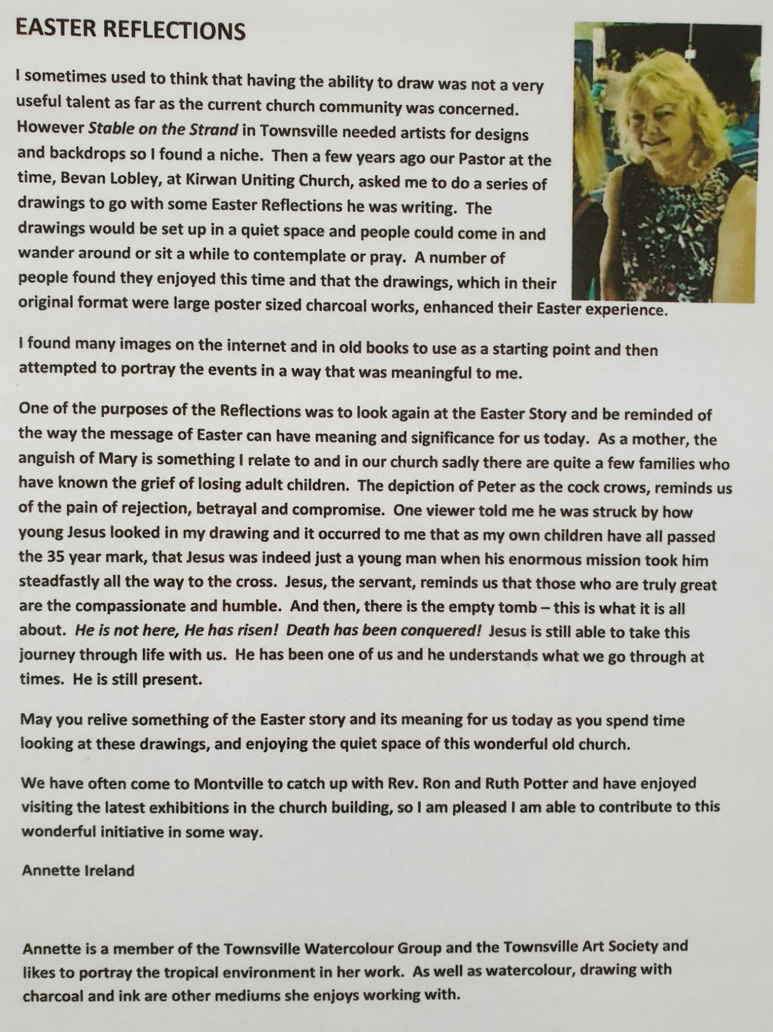
Ruth Potter and Barbara Willcocks
rpotter@westnet.com.au 07 5478 6484 or 0455 444 453
barbara.willcocks@gmail.com 07 5478 6995 or 0403 541 257

