Newsletter 39 12 April 2023

Friends of the Reflection Gallery
“Reflecting faith’s experience”
An activity of the Montville Uniting Church
Thank you, Annette
For two weeks, including the Easter period, we have enjoyed hosting Annette Ireland’s series of Drawings Easter Story, and we are very grateful to Annette for her generous support of the gallery.
Welcome Rev Geraldine Wheeler
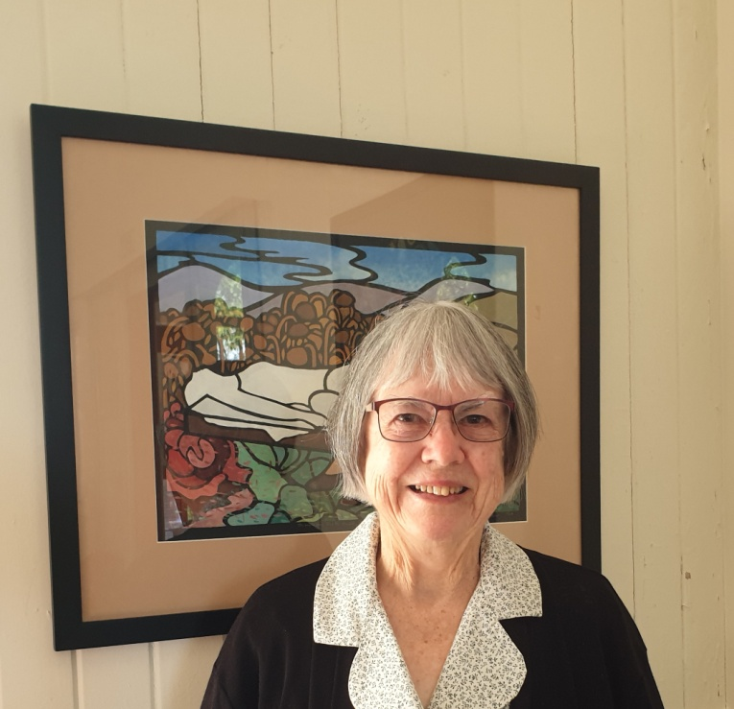
Today a new display was installed in the church. Rev. Geraldine Wheeler visited Umbria in Italy in 2007 and this set her on the pathway to developing a series of paintings illustrating the poem Canticles of the Creatures by St Francis of Assisi.
Her artist’s biography reads as follows: Geraldine Wheeler is a retired minister of the Uniting Church in Australia who has been using images as visual interpretation of scripture to complement preaching and teaching in words and as a means of entering into prayer and meditation for several decades. She has drawn, painted and made prints from school days, studying art at high school and taking adult classes with artists such as Clem Forbes, Wim de Vos and Michael Winters. She is three times winner of the Maleny Art Awards Christian Theme section and is founder/co-ordinator of the ecumenical group of artists in S. E. Queensland, Visionaries. Her Ph. D. thesis (ACU 2004) examined the possibilities for the role of visual art within the theological understanding of the Reformed Tradition of Christianity.

The Canticle of the Creatures
The poem/song by Francis of Assisi, written 1224, presents the idea of all creation joining in praise of its Creator, specifically mentioning sun and moon; air, water, fire, earth; flowers and fruit; the forgiving and humble heart, and death. The key expression is “Be praised, my Lord, through all your creatures”.
Hymn 100 in Together in Song, All creatures of our God and King, is a paraphrase by Dr William Henry Draper then Rector of Adel, now a suburb of Leeds, Yorkshire. It was written for a children’s Whitsuntide Festival in that city in 1910.
The Paintings
Stencil prints are made firstly by drawing and cutting the stencil, then painting through the stencil in gouache paint onto black paper. Geraldine writes, “It is a technique I began to experiment with after doing hand coloured linocuts. (I had read about Margaret Preston’s borrowing from a Japanese stencil technique when she could no longer do wood cuts and I had seen examples of her stencil print work.)”
List of works in order are:
- Be praised, my Lord, through all your creatures, Rose Window 1
- Through Brother Sun
- Through Sister Moon and the Stars
- Through Brother Wind and Air
- Through Sister Water
- Through Brother Fire
- Through our Sister Mother Earth
- Through Those who Forgive for Love of You
- Through our Sister Bodily Death
- Be praised, my Lord, through all your creatures, Rose Window 2

Thank you to our Friends

Please continue to promote the Reflection Gallery. Tell your friends about it and suggest that when they are making a visit to Montville they put a visit to the gallery on their to-do list. The current display will remain in place until the end of June.

Ruth Potter and Barbara Willcocks
rpotter@westnet.com.au 07 5478 6484 or 0455 444 453
barbara.willcocks@gmail.com 07 5478 6995 or 0403 541 257

