Newsletter 45 20 April, 2024
Friends of the Reflection Gallery
“Reflecting faith’s experience”
An activity of the Montville Uniting Church
Greetings to you Friend
Today we installed Wendy Jarrott Smith’s “Nourish and Flourish” artworks in the Reflection Gallery. The previous display was there throughout March and featured Dr Gregg Nowell’s Stations of the Cross series.
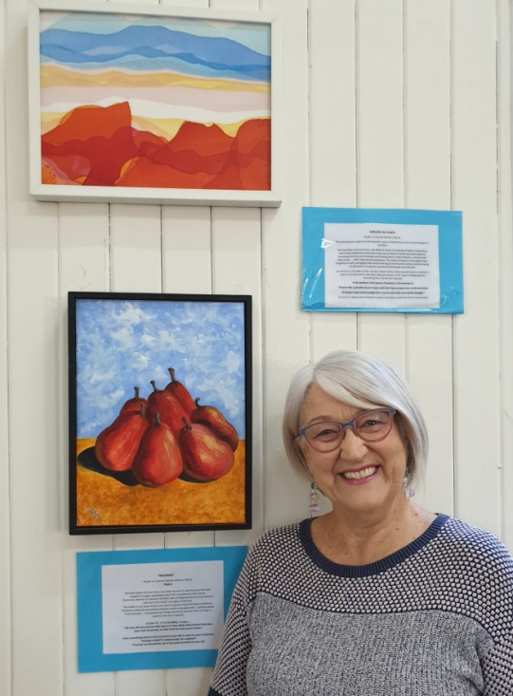
Wendy writes “Standard apple and pear trees can easily flourish for over 50 years, but their longevity is hugely dependent upon their nourishment and nurture. Good soil; attention to indicators of disease; fertiliser; rain and appropriate pruning methods will add to the health and vigour of the tree.

The health of our souls, bodies and spirits requires much the same conditions. Physical, emotional and spiritual disease needs to be dealt with…nutrition needs to be provided…. and sometimes things need to be ‘pruned’ from our lives in order for new life to flourish.

In John 15 : 1-3 in the Bible, it says…..
“He cuts off every branch that bears no fruit, while every branch that does bear fruit He prunes, so that it will be even more fruitful.”

About 7 years ago, an unexpected illness ‘pruned back my life’, but also gave me more time and ‘creative space’ in my world, to be able to commit to painting and writing more regularly. For me, it was a time to ‘NOURISH and FLOURISH’, and the name of my exhibit today!
Is something being pruned from your life at the moment?
Perhaps a habit? A relationship? An unbelief?
Is this a chance for you to flourish in a new way?
‘Pruning’ can be painful, but it has great benefits for your life.
May my paintings and reflections be an encouragement to you to ‘nourish and flourish’, wherever you are today, on the journey of life! Warmly.” Thank you, Wendy, for sharing your witness with us in this way.
The Visitors Book continues to give some indication of the worldwide reach of the gallery. The aim of providing a place for quiet reflection seems to be being realized.
Thank you for your support. Please continue to pray for the Gallery and its outreach, for the people that visit it, for Wendy, the artist whose work is now on display and for Gregg.
Grace and peace to you.
Ruth Potter and Barbara Willcocks
rpotter@westnet.com.au 07 5478 6484 or 0455 444 453
barbara.willcocks@gmail.com 0403 541 257

