

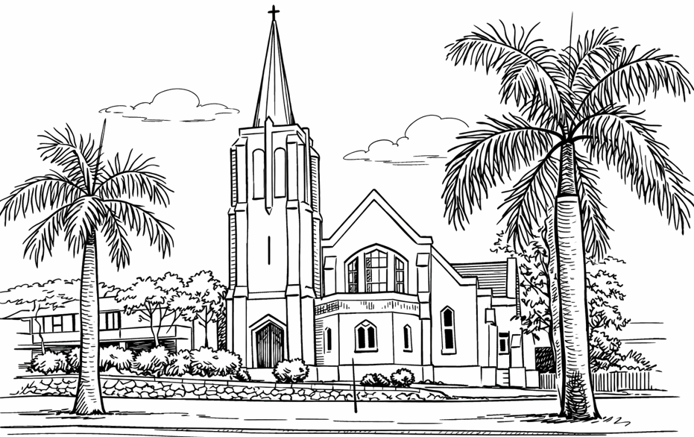
From the Desk of the Minister
Collect: Grant, O merciful God, that your church, being gathered together in unity by your Holy Spirit, may show forth your power among all peoples, to the glory of your Name; through Jesus Christ our Lord, who lives and reigns with you and the Holy Spirit, one God, for ever and ever. Amen.
The church is built on the solid Rock
This morning the gospel of Matthew is talking about the conversation of Jesus and his disciples at Caesarea Philippi. It is important to know the background of this place. It is located at the foot of Mt. Hermon in the Northern part of Israel. It was a heavily pagan area filled with shrines to Greek and Roman gods. It was always linked with idol worship.
Maybe Jesus was intentional in leaving the question to be asked at this location. Seeing all the backgrounds of this city, and in the midst of all this, Jesus asks a question he has never asked his disciples before – “Who do people say the Son of Man is?” One by one they began to answer…but Jesus was not interested in what others were saying about him. He was simply preparing the disciples for the question of all questions: “But what about you?” “Who do you say I am?” Maybe they were looking to each other with a smile, but Simon Peter without hesitation said – “You are the Messiah, the Son of the Living God.” Jesus replied, “Blessed are you Simon son of Jonah, for this was not revealed to you by flesh and blood, but my Father in heaven. And I tell you that you are Peter, and on this rock I will build my church, and the gates of Hades will not overcome it.”
Jesus Christ is the Rock where the church is built. The church belongs to Christ who loved the church, and gave himself for it. The faith of all the followers of Christ will become the solid Rock on which the church is built. It is not important what others say about Jesus, it is what we know about Him that really counts. Who is Jesus for you???
Grace & Peace. Maile

Nambour Uniting Church
9AM Sunday Worship Service
23 August 2026

Join Us for fellowship after service every Sunday.
Nambour Village Services August 2026
Bowder 2 August11am Rev Maile
Estia 6 August 10am
Rotary 18 August 2pm Rev Maile

Ministry
Reverend Maile 0425 378 174
Pastoral Care Ministry
Rev Graham Warne 5478 9747
Congregation Chairperson
Ian Woodward 5441 1069
Church Office
5441 1135
Office: most Tuesdays and Thursdays from 10am to 2pm

NAMBOUR UNITING CHURCH 37-39 Coronation Avenue Nambour QLD 4560
PO Box 1100 Nambour QLD 4560 Opposite Nambour State College
CHURCH EMAIL nambouruca@gmail.com
FACEBOOK facebook.com/nambouruniting.church
WEBPAGE nambouruniting.org.au
YOUTUBE CHANNEL nambouruca.youtube


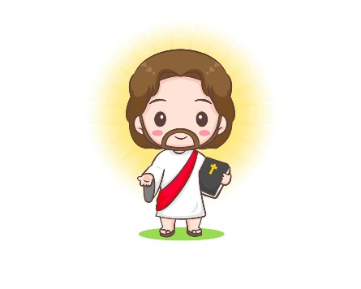
Activities in our Church this week
23 August 2026
Sunday: Worship Service at 9am
Tuesday: Indoor Bowls 9am – 12pm
Tuesday Bible Study 9am – 10am
Tuesday: Narcotics Australia 12pm – 2pm
Wednesday Tai Chi 9am – 11am
Thursday: Indoor Bowls 9am – 12pm
Thursday: Narcotics Australia 12pm – 2pm
Friday Church Choir 4pm – 5pm
Friday Young adults Bible Study 5pm – 7pm
Saturday Orchid Society 12pm – 4pm
Saturday: Narcotics Australia 6pm-9pm
Happy Birthday to you!
25 August Lee Goleby
22 August Ken Roberts

God Bless you on your Special Day
Church Announcements & Reminders:

If you would like anything posted in the newsletter please advise via email caitlincoote@hotmail.com

If you would like to put an announcement in an upcoming Nexus please let Caitlin know via email: caitlincoote@hotmail.com. Cut off is 6pm Wednesday for the upcoming Sunday.
Young Adults Bible Study Friday from 5pm
Cultural Lunch 12 September
Vanderbilt Lectionary
Bible readings for Next Sunday
Proper 17(22)
30 August 2026
Exodus 3:1-15 and Psalm 105:1-6, 23-26, 45b
Jeremiah 15:15-21 and Psalm 26:1-8
Romans 12:9-21
Matthew 16:21-28
Sunday school will be cancelled in August. It will resume on the 20th September and we would appreciate donations of small jars ( clear with lids) for our next activity. God bless 🙏

Proverbs for Daily Living
“Faith is an oasis in the heart which will never be reached by the caravan of thinking.”
Khalil Gilbran
“Faith is not the belief that God will do what you want. It is the belief that God will do what is right.”
Max Lucado

Service Roster
23 August 2026
Proper 16 (21)
Minister: Rev Maile
Music:
Readers: Judy & Peter Moore
Prayers: Graham Warne
Data Projector: Chris Bowden
Offering: Weekly retiring offering
Welcome: Our great welcoming team
Thank you to our volunteers this week
Vanderbilt Lectionary
Readings for Today
Proper 16 (21)
23 August 2026
Exodus 1:8-2:10 & Psalm 124
Isaiah 51:1-6 & Psalm 138
Romans 12:1-8
Matthew 16:13-20

