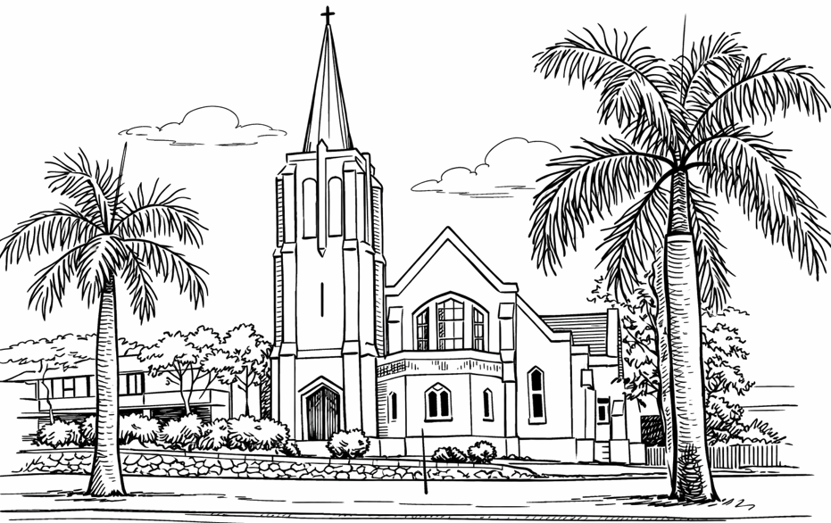


Join Us for fellowship after service every Sunday.
From the Desk of the Minister

A massive Thank-you to Everyone from our Church Family who helped in various ways with our 2026 Carparking Fundraisers over 4 weekends.

Thanks for all the time we shared together getting to know each other better and growing stronger friendships,for your welcoming smiles and kind greetings, patience and care for the more than 3500 people who sharedour property over the 4 weekends this year, and for safely helping park nearly 1400 vehicles.

Together we raised a significant Total of $ 13 573 which greatly assists the on-going life of our Congregation.

Thanks to All members of our Congregation for your Prayers of safety for all involved during the events.

The wise collective decision is that our 2027 focus for our teams is 2 events only,
Sunshine Coast Show and Qld Garden Show as they produced 94% of total fundraising.

Thanks again🙏

Nambour Village Services August 2026
Bowder 2 August11am Rev Maile
Estia 6 August 10am
Rotary 18 August 2pm Rev Maile

Nambour Uniting Church
9AM Sunday Worship Service
30 August 2026

Ministry
Reverend Maile 0425 378 174
Pastoral Care Ministry
Rev Graham Warne 5478 9747
Congregation Chairperson
Ian Woodward 5441 1069
Church Office
5441 1135
Office: most Tuesdays and Thursdays from 10am to 2pm

NAMBOUR UNITING CHURCH 37-39 Coronation Avenue Nambour QLD 4560
PO Box 1100 Nambour QLD 4560 Opposite Nambour State College
CHURCH EMAIL nambouruca@gmail.com
FACEBOOK facebook.com/nambouruniting.church
WEBPAGE nambouruniting.org.au
YOUTUBE CHANNEL nambouruca.youtube




Young Adults Bible Study Friday from 5pm

Cultural Lunch 12 September
Happy Birthday to you!

01 September Emily Euno-Dewhurst
01 September Ken Warland

God Bless you on your Special Day
Church Announcements & Reminders:

If you would like anything posted in the newsletter please advise via email caitlincoote@hotmail.com

If you would like to put an announcement in an upcoming Nexus please let Caitlin know via email: caitlincoote@hotmail.com. Cut off is 6pm Wednesday for the upcoming Sunday.
Sunday school will be cancelled in August. It will resume on the 20th September and we would appreciate donations of small jars( clear with lids) for our next activity. God bless 🙏

Activities in our Church this week
30 August 2026
Sunday: Worship Service at 9am
Monday Sunshine Linus 08:30-2:30pm
Tuesday: Indoor Bowls 9am – 12pm
Tuesday: Narcotics Australia 12pm – 2pm
Wednesday Tai Chi 9am – 11am
Wednesday: English Class 7pm - late
Thursday: Narcotics Australia 12pm – 2pm
Friday Orchid Show 07:30-4pm
Saturday Orchid Show 07:30-4pm
Saturday: Narcotics Australia 6pm-9pm
Proverbs for Daily Living
“Faith is an oasis in the heart which will never be reached by the caravan of thinking.”
Khalil Gilbran
“Faith is not the belief that God will do what you want. It is the belief that God will do what is right.”
Max Lucado

Vanderbilt Lectionary
Bible readings for Next Sunday
Proper 18(23)
06 September 2026
Exodus 12:1-14 and Psalm 149
Ezekiel 33:7-11 and Psalm 119:33-40
Romans 13:8-14
Matthew 18:15-20
Service Roster
30 August 2026
Proper 17 (22)
Minister: Rev Maile
Music: Margaret
Readers: Losa Molitika & David Roff
Prayers: Rev Maile
Data Projector: Losa Molitika
Offering: Weekly retiring offering
Welcome: Our great welcoming team
Thank you to our volunteers this week
Vanderbilt Lectionary
Readings for Today
Proper 17 (22)
30 August 2026
Exodus 3:1-15 & Psalm 105:1-6, 23-26, 45b
Jeremiah 15:15-21 Psalm 26:1-8
Romans 12:9-21
Matthew 16:21-28

